Map 1
Hedge rows with trees, on skyline overlooking village to the west
1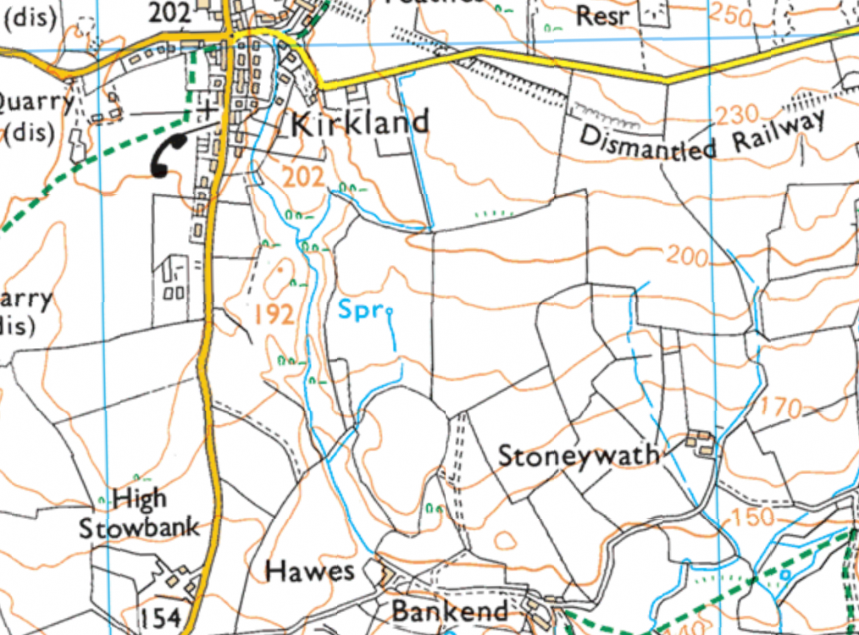
Steep bank grass and tree gully with watercourse in bottom over looking house to the south
Deep glacial gully with trees, bracken and gorse, leading up banks with some trees and watercourse in bottom
Grid references
Plot 1 – NY 0717 5288, 1.7 ha
Plot 2- NY 0717 3371, 3.0 ha
Plot 3 – NY 0717 4024, 0.8 ha
Plot 3
Plot 2
Plot 1
Map 2
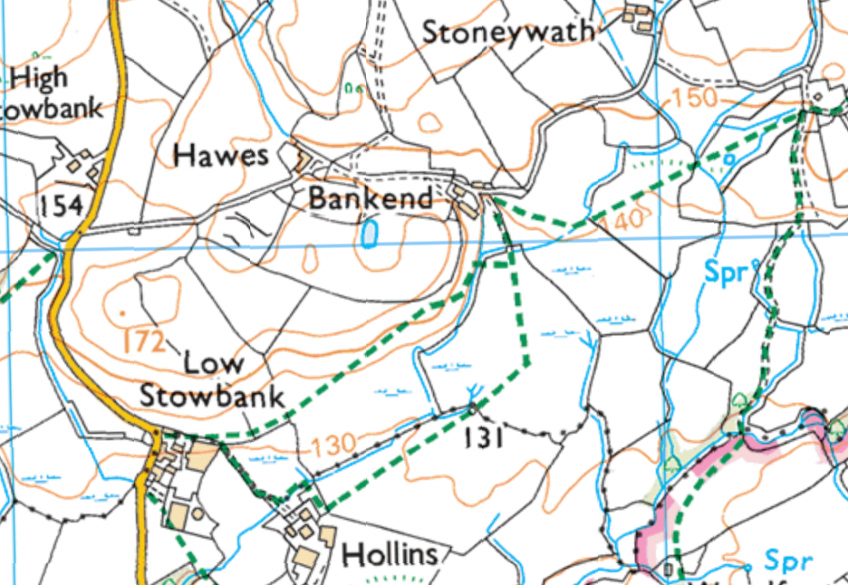
Grass land with rushes present, with hedges and trees in in hedges flate terrain
Grassy bank leading down to Gill, some trees and gorse along with Tree stumps , public foot path crosses west to east
Grassy bank with tree along skyline, next to house has power lines running west to east
Grid references
Plot 4- NY 0717 6007. 0.6 ha
Plot 5 – NY 0716 6991, 1 ha
Plot 6 – NY 0716 8689, 1.1 ha
Plot 7 – NY 0817 0202, 1.2 ha
Plot 8 - NY 0716 4971, 1.2 ha
Plot 9 - NY 0716 1263
Plot 9
Plot 8
Plot 7
Plot 6
Plot 5
Plot 4
Map 3
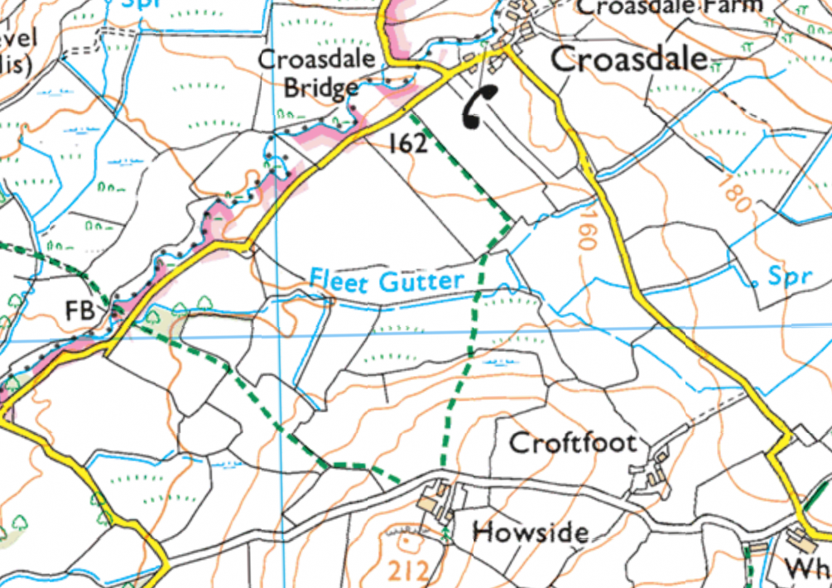
Sloping ground from north to south, grass and rushes present with water courses in hedgerows along with trees
Powerlines present in fields
Flat terrain Fields surrounded by trees and hedges alongside water courses
Grid refences
Plot 10 – NY 0816 7874, 2.1 ha
Plot11 – NY 0916 0199, 1.6 ha
Plot 12 – NY 0917 2308, 0.8 ha
Plot 13 – NY 0817 9329. 0.7 ha
Plot 14 – NY 0917 4706, 1.1 ha
Plot 15 – NY 0917 5025, 0.2 ha
Plot 16 – NY 0917 5732, 1.7 ha
Plot 16
Plot 15
Plot 14
Plot 13
Plot 12
Plot 11
Plot 10
Map 4 SPA AND SAC Locations
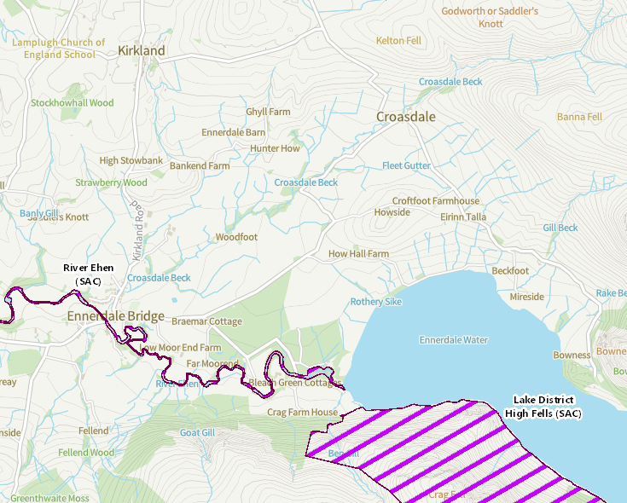
Distance of Plats for River Ehen and Lake District National Park SAC (km)
Plot | Ehen | LDNP
1 | 2.1 | 3.2
2 | 1.8 | 3
3 | 1.4 | 2.9
4 | 1.4 | 2.6
5 | 1.2 | 2.5
6 | 1.3 | 2.2
7 | 1.5 | 2.3
8 | 1 | 2.5
9 | 0.9 | 2.7
10 | 1.2 | 1.7
11 | 1.6 | 1.8
12 | 1.6 | 1.8
13 | 1.7 | 1.9
14 | 1.6 | 2
15 | 1.6 | 2
16 | 1.8 | 2.2

